**ANT COLONY OPTIMIZATION**

**SEMINAR REPORT**

***Submitted by:***

1. **GEETHA SRI**

**188T1A0544**

**to**

**the JNTU, Kakinada**

**In partial fulfillment of the requirements for the**

**Award of the degree of**

**BACHELOR OF TECHNOLOGY**

**IN**

**COMPUTER SCIENCE & ENGINEERING**

**AT**

**DHANEKULA INSTITUTE OF ENGINEERING &TECHNOLOGY**

**GANGURU, A.P. (INDIA) – 521139**

**(AFFILIATED TO JNTUK, KAKINADA, ANDHRA PRADESH (INDIA), JUNE 2022)**

**DECLARATION**

I hereby declare that the seminar entitled “**Ant Colony Optimization**” was carried out and written by me under the guidance of Professor Dr. K. Srinivasa Rao, Department of Computer Science & Engineering, Dhanekula Institute of Engineering and Technology, Ganguru. This work has not been previously formed the basis for the award of any degree or certificate nor has been submitted elsewhere for the award of any degree.

**P. GEETHA SRI(188T1A0544)**

**Place:**

**Date:**

**CERTIFICATE**

This is to certify that the seminar topic titled “**ANT COLONY OPTIMIZATION**” is the bonafide work carried out by **P. GEETHA SRI(188T1A0544)**,a student of B Tech(CSE) of Dhanekula Institute of Engineering and Technology, affiliated to JNT University, Kakinada, AP(India) during the academic year 2021-22, in partial fulfillment of the requirements for the award of the degree of Bachelor of Technology(Computer Science and Engineering ) and that the project has not formed the basis for the award previously of any other degree, diploma, fellowship or any other similar title.

**P. GEETHA SRI(188T1A0544)**

**Place:**

**Date:**

**VISION – MISSION - PEOs**

|  |  |
| --- | --- |
| Institute Vision | Pioneering Professional Education through Quality |
| Institute Mission | Providing Quality Education through state-of-art infrastructure, laboratories and committed staff.  Moulding Students as proficient, competent, and socially responsible engineering personnel with ingenious intellect.  Involving faculty members and students in research and development works for betterment of society. |
| Department Vision | To empower students of Computer Science and Engineering Department to be technologically adept, innovative, global citizens possessing human values. |
| Department Mission | To Encourage students to become self-motivated and problem solving individuals.  To prepare students for professional career with academic excellence and leadership skills.  To Empower the rural youth with computer education.  To Create Centre’s of excellence in Computer Science and Engineering. |
| Program Educational Objectives (PEOs) | Graduates of Computer Science & Engineering will:  **PEO1:** Excel in Professional career through knowledge in mathematics and engineering principles.  **PEO2:** Able to pursue higher education and research.  **PEO3:** Communicate effectively, recognize, and incorporate societal needs in their professional endeavors.  **PEO4:** Adapt to technological advancements by continuous learning. |

**POs/PSOs**

**PROGRAM OUTCOMES**

|  |  |
| --- | --- |
| **1** | **Engineering Knowledge:** Apply the knowledge of mathematics, science, engineering fundamentals and an engineering specialization to the solution of complex engineering problems. |
| **2** | **Problem analysis**: Identify, formulate, review research literature, and analyze complex engineering problems reaching substantiated conclusions using first principles of mathematics, natural sciences, and engineering sciences. |
| **3** | **Design/development of solutions**: Design solutions for complex engineering problems and design system components or processes that meet the specified needs with appropriate consideration for the public health and safety, and the cultural, societal, and environmental considerations |
| **4** | **Conduct investigations of complex problems**: Use research-based knowledge and research methods including design of experiments, analysis and interpretation of data, and synthesis of the information to provide valid conclusions. |
| **5** | **Modern tool usage**: Create, select, and apply appropriate techniques, resources, and modern engineering and IT tools including prediction and modeling to complex engineering activities with an understanding of the limitations. |
| **6** | **The engineer and society**: Apply reasoning informed by the contextual knowledge to assess societal, health, safety, legal and cultural issues and the consequent responsibilities relevant to the professional engineering practice. |
| **7** | **Environment and sustainability**: Understand the impact of the professional engineering solutions in societal and environmental contexts, and demonstrate the knowledge of, and need for sustainable development. |
| **8** | **Ethics**: Apply ethical principles and commit to professional ethics and responsibilities and norms of the engineering practice. |
| **9** | **Individual and team work**: Function effectively as an individual, and as a member or leader in diverse teams, and in multidisciplinary settings. |
| **10** | **Communication**: Communicate effectively on complex engineering activities with the engineering community and with society at large, such as, being able to comprehend and write effective reports and design documentation, make effective presentations, and give and receive clear instructions. |
| **11** | **Project management and finance**: Demonstrate knowledge and understanding of the engineering and management principles and apply these to one’s own work, as a member and leader in a team, to manage projects and in multidisciplinary environments. |
| **12** | **Life-long learning**: Recognize the need for, and have the preparation and ability to engage in independent and life-long learning in the broadest context of technological change. |

**PROGRAM SPECIFIC OUTCOMES**

**PSO1:** Have expertise in algorithms, networking, web applications and software engineering for efficient design of computer-based systems of varying complexity.

**PSO2:** Qualify in national international level competitive examinations for successful higher studies and employment.

**ACKNOWLEDGEMENT**

I would like to take this opportunity to express our deep gratitude to the members who assisted us directly and indirectly for the completion of this seminar work.

I would like to express our immense pleasure in expressing immeasurable sense of gratitude to **Dr. S. SURESH, Professor & Head of the Department in Computer Science of Engineering** for his valuable suggestions in the completion of the project.

I whole heartedly acknowledge **Dr. RAVI KADIYALA (Principal), Mr. A. Srinivasa Rao (Professor, Seminar Coordinator), Krishna Kishore (Assistant Professor, Seminar Coordinator) and Sudheer (Seminar Coordinator)** for giving opportunity to make this seminar a successful one.

I also extend my thanks to all the faculty members of Computer Science and Engineering Department for their valuable contributions in this seminar.

I would like to extend my warm appreciation to all our friends for sharing their knowledge and valuable contributions in this project.

Finally, I express my deep sense of gratitude to my parents for their continuous support throughout our academic career and their encouragement in completion of this seminar successfully.

**P. GEETHA SRI(188T1A0544)**

**SEMINAR MAPPINGS**

|  |  |
| --- | --- |
| **Student Roll No** | **Student Name** |
| 188T1A0544 | P. GEETHA SRI |
| **Seminar Title** | ANT COLONY OPTIMIZATION |
| **Seminar Domain** | ARTIFICIAL INTELLIGENCE |

|  |  |  |  |  |  |  |  |  |  |  |  |  |  |  |
| --- | --- | --- | --- | --- | --- | --- | --- | --- | --- | --- | --- | --- | --- | --- |
| **Project Title** | **PO**  **1** | **PO2** | **PO3** | **PO4** | **PO5** | **PO6** | **PO7** | **PO8** | **PO9** | **PO**  **10** | **PO**  **11** | **PO**  **12** | **PSO1** | **PSO2** |
| ARTIFICIAL PASSENGER | **3** | **3** | **3** | **3** | **3** | **3** | **3** | **3** | **3** | **3** | **3** | **3** | **3** | **3** |

|  |  |
| --- | --- |
| **Mapping Level** | **Mapping Description** |
| 1 | Low Level Mapping with PO & PSO |
| 2 | Moderate Mapping with PO & PSO |
| 3 | High Level Mapping with PO & PSO |

**P Geetha Sri** **A. Srinivasa Rao**

**Member Seminar Coordinator**

**MAPPING JUSTIFICATION**

* **PO1:**Apply the knowledge of artificial intelligence involved in computer science specialization like facial recognition for the detection of drowsiness.
* **PO2:** Identify and analyze the problems that are caused in detecting drowsiness of driver.
* **PO3:** Design an application that can detect the drowsiness of passenger and alert the driver by mapping the facial expressions accordingly.
* **PO4:**Use the research-based knowledge of the existing solutions to analyze the data and to provide accurate results for drowsiness detection.
* **PO5:** Use the modern libraries and techniques such as OpenCV and Keras which is available in python for monitoring eye movements to detect the drowsiness of driver.
* **PO6:** Apply the knowledge and develop a model that is used by the society for better results in artificial passenger by alerting driver to prevent drowsiness by using facial expressions and eye movements thereby helps to reduce accident percentage.
* **PO7:** Use of this artificial passenger model does not affect the environment and provides accurate results which contributes sustainable development.
* **PO8:**Commit to professional principles and engineering norms in development of the solution.
* **PO9:**Work effectively as an Individual and as Team during the development of solution to the problem.
* **PO10:**Communicate effectively about the solution that is developed through documentation, reports and presentation for better understanding.
* **PO11:**Manage the seminar with the team that involves various techniques that are performed like data analysis and the developing environment that is used.
* **PO12:**This seminar can be further developed and has a higher scope and many improvements can be further made.Learn python for the development.
* **PSO1:**Seminar deals with artificial intelligence techniques that are to be applied to obtain solutions.
* **PSO2:** During seminar helps students to acquire employment skills

**ABSTRACT**

Swarm intelligence is a relatively new approach to problem solving that takes inspiration from the social behaviors of insects and of other animals. In particular, ants have inspired a number of methods and techniques among which the most studied and the most successful is the general purpose optimization technique known as ant colony optimization. Ant colony optimization (ACO) takes inspiration from the foraging behavior of some ant species. These ants deposit pheromone on the ground in order to mark some favorable path that should be followed by other members of the colony. Ant colony optimization exploits a similar mechanism for solving optimization problems. From the early nineties, when the first ant colony optimization algorithm was proposed, ACO attracted the attention of increasing numbers of researchers and many successful applications are now available. Moreover, a substantial corpus of theoretical results is becoming available that provides useful guidelines to researchers and practitioners in further applications of ACO. The goal of this article is to introduce ant colony optimization and to survey its most notable applications.

**TABLE OF CONTENTS**

1. **INTRODUCTION**
   1. Swarm Intelligence……………………………………………………..12
   2. Ant Colony……………………………………………………………..13
   3. Real Ant Behaviour…………………………………………………….14
   4. Behaviour of ant in presence of an obstacle……………………………15
2. **ANT COLONY OPTIMIZATION…………………………...17**
3. **APPLICATIONS OF ACO**
   1. Travelling Sales man……………………………………………………21
   2. Quadratic Assignment Problem(QAP)………………………………….26
   3. Network Model………………………………………………………….28
   4. Vehicle Routing Problem with Time Windows…………………………30
4. **ADVANTAGES OF ACO……………………………………..32**
5. **DISADVANTAGES OF ACO…………………………………32**
6. **CONCLUSION…………………………………………………33**
7. **REFERENCES…………………………………………………34**

**INTRODUCTION**

* 1. **Swarm Intelligence:**

Swarm intelligence (SI) describes the [collective behaviour](http://en.wikipedia.org/wiki/Collective_behavior) of [decentralized](http://en.wikipedia.org/wiki/Decentralization), [self-](http://en.wikipedia.org/wiki/Self_organization) [Organized](http://en.wikipedia.org/wiki/Self_organization) systems, natural or artificial. The concept is employed in work on [artificial](http://en.wikipedia.org/wiki/Artificial_intelligence) [intelligence](http://en.wikipedia.org/wiki/Artificial_intelligence). The expression was introduced by [Gerardo Beni](http://en.wikipedia.org/wiki/Gerardo_Beni) and [Jing Wang](http://en.wikipedia.org/w/index.php?title=Jing_Wang&action=edit&redlink=1) in 1989, in the context of [cellular robotic](http://en.wikipedia.org/wiki/Cellular_automaton) systems.

Swarm intelligence is the discipline that deals with natural and artificial systems composed of many individuals that coordinate using decentralized control a[nd self-organization](http://www.scholarpedia.org/article/Self-organization). In particular, the discipline focuses on the collective behaviors that result from the local interactions of the individuals with each other and with their environment. Examples of systems studied by swarm intelligence are colonies of ants and termites, schools of fish, flocks of birds, herds of land animals. Some human artifacts also fall into the domain of swarm intelligence, notably some multi-robot systems, and also certain computer programs that are written to tackle [optimization](http://www.scholarpedia.org/article/Optimization) and data analysis problems.

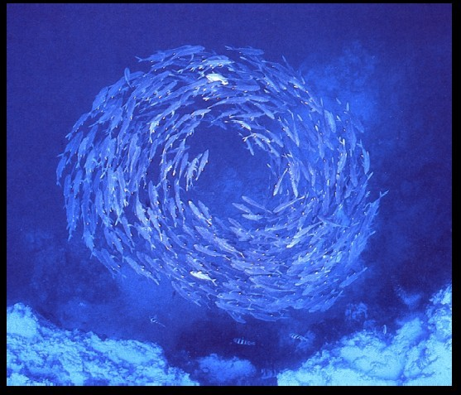Emphasis is given to such topics as the modelling and analysis of collective biological systems; application of biological swarm intelligence models to real-world problems; and theoretical and empirical research in ant colony optimization, particle swarm optimization, swarm robotics, and

other swarm intelligence algorithms. Articles often combine experimental and theoretical work

* 1. **Ant Colony:**

The complex social behaviors of ants have been much studied by science, and computer scientists are now finding that these behaviour patterns can provide models for solving difficult combinatorial optimization problems. The attempt to develop algorithms inspired by one aspect of ant behaviour, the ability to find what computer scientists would call shortest paths, has become the field of ant colony optimization (ACO), the most successful and widely recognized algorithmic technique based on ant behaviour. This book presents an overview of this rapidly growing field, from its theoretical inception to practical applications, including descriptions of many available ACO algorithms and their uses.

The book first describes the translation of observed ant behaviour into working optimization algorithms. The ant colony metaheuristic is then introduced and viewed in the general context of combinatorial optimization. This is followed by a detailed description and guide to all major ACO algorithms and a report on current theoretical findings. The book surveys ACO applications now in use, including routing, assignment, scheduling, subset, machine learning, and bioinformatics problems. AntNet, an ACO algorithm designed for the network routing problem, is described in detail. The authors conclude by summarizing the progress in the field and outlining future research directions. Each chapter ends with bibliographic material, bullet points setting out important ideas covered in the chapter, and exercises. *Ant Colony Optimization* will be of interest to academic and industry researchers, graduate students, and practitioners who wish to learn how to implement ACO algorithms.

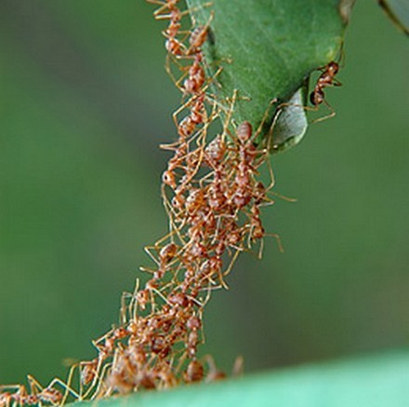

**1.3 Real Ant Behavior :**

Natural behaviour of ants have inspired scientists to mimic insect operational methods to solve real-life complex problems such as Travelling sales man problem, Quadratic assignment problem, Network model, Vehicle routing. By observing ant behaviour, scientists have begun to understand their means of communication

Ants communicate with each other through tapping with the antennae and smell. They are considered, together with the bees, as one of the most socialized animals. They have a perfect social organization, and each type of individual specializes in a specific activity within the colony. They are thought by many as having a collective intelligence, and each ant is considered then as an individual cell of a bigger organism. Ants wander randomly & on

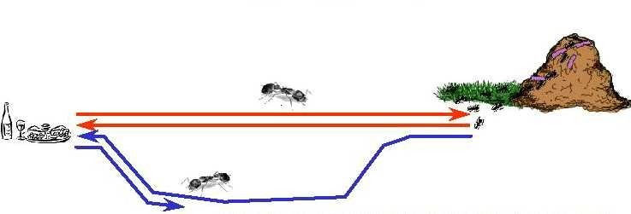

finding food return to their colony while laying “PHEROMONE TRIALS”.

If other Ants find such paths they do not travel randomly but follow the Pheromone trail. Ants secrete pheromone while travelling from the nest to food and vice versa in order to communicate with each other to find shortest path.

Pheromone is a highly volatile substance which starts to evaporate, more the time taken by the ant to travel to and fro more time the pheromone have to evaporate. A shortest path gets marched over faster and thus the pheromone density remains high. If one of the ant finds the shortest path from colony to food source other ants are more likely to follow the same path.

**1.4 Behaviour of ant in presence of an obstacle:**

Ants are forced to decide whether they should go left or right. The choice that is made is a random one. Pheromone accumulation is Faster on shortest path.

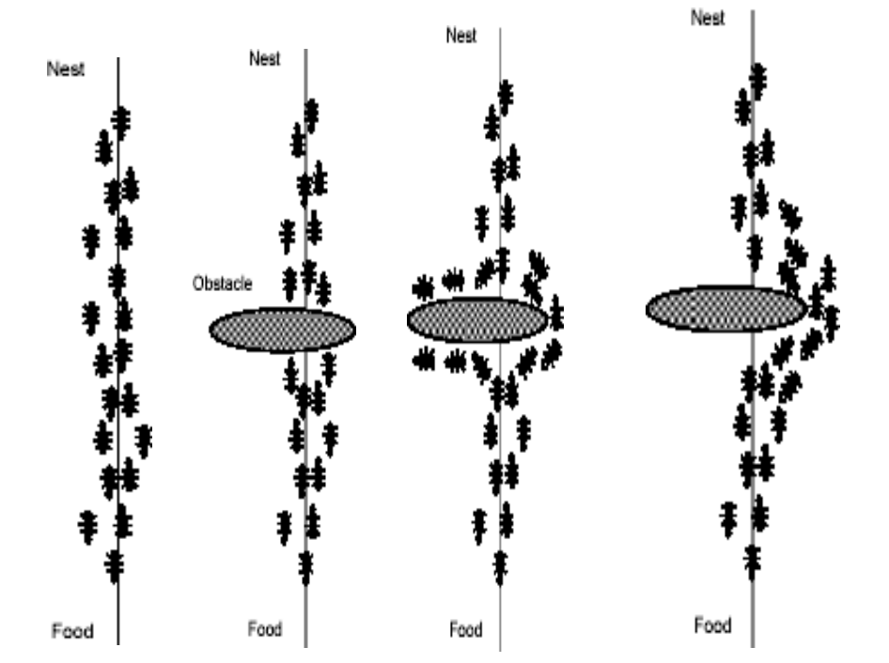

**Ants:**

One of the first researchers to investigate the social behaviour of insects was the French entomologist Pierre-Paul Grasse. In the forties and fifties of the 20-th century, he was observing the behaviour of termites in particular, the Bellicositermes natalensisand Cubitermesspecies. He discovered [26] that these insects are capable to react to what he called significant stimuli", signals that activate a genetically encoded reaction. He observed that the effects of these reactions can act as new significant stimuli for both the insect that produced them and for the other insects in the colony. Grasse used the term stigmergyto describe this particular type of indirect communication in which the workers are stimulated by the performance they have achieved". The two main characteristics of stigmergy that differentiate it from other means of communication are:

* the physical, non-symbolic nature of the information released by the communicating insects, which corresponds to a modification of physical environmental states visited by the insects
* the local nature of the released information, which can only be accessed by those insects that visit the place where it was released (or its immediate neighbourhood).

Examples of stigmergy can be observed in colonies of ants. In many ant species, ants walking to, and from, a food source deposit on the ground a substance called pheromone. Other ants are able to smell this pheromone, and its presence influences the choice of their path i.e., they tend to follow strong pheromone.

1. **Ant Colony Optimization(ACO):**

Ant Colony Optimization (ACO) is a paradigm for designing metaheuristic algorithms for combinatorial optimization problems. The first algorithm which can be classified within this framework was presented in 1991 and, since then, many diverse variants of the basic principle have been reported in the literature.

The essential trait of ACO algorithms is the combination of a priori information about the structure of a promising solution with posterior information about the structure of previously obtained good solutions. Metaheuristic algorithms are algorithms which, in order to escape from local optima, drive some basic heuristic: either a constructive heuristic starting from a null solution and adding elements to build a good complete one, or a local search heuristic starting from a complete solution and iteratively modifying some of its elements in order to achieve a better one.

The metaheuristic part permits the low-level heuristic to obtain solutions better than those it could have achieved alone, even if iterated. Usually, the controlling mechanism is achieved either by constraining or by randomizing the set of local neighbour solutions to consider in local search (as is the case of simulated annealing [ or tabu ), or by combining elements taken by different solutions (as is the case of evolution strategies and genetic or bionomic algorithms).

The characteristic of ACO algorithms is their explicit use of elements of previous solutions. In fact, they drive a constructive low-level solution, as GRASP does, but including it in a population framework and randomizing the construction in a Monte Carlo way. A Monte Carlo combination of different solution elements is suggested also by Genetic Algorithms , but in the case of ACO the probability distribution is explicitly defined by previously obtained solution components. The particular way of defining components and associated probabilities is problem- specific, and

can be designed in different ways, facing a trade-off between the specificity of the information used for the conditioning and the number of solutions which need to be constructed before effectively biasing the probability distribution to favour the emergence of good solutions. Different applications have favoured either the use of conditioning at the level of decision variables, thus requiring a huge number of iterations before getting a precise distribution, or the computational efficiency, thus using very coarse conditioning information. The chapter is structured as follows. Section 2 describes the common elements of the heuristics following the ACO paradigm and outlines some of the variants proposed. Section 3 presents the application of ACO algorithms to a number of different combinatorial optimization problems and it ends with a wider overview of the problem attacked by means of ACO up to now. Section 4 outlines the most significant theoretical results so far published about convergence properties of ACO variants.

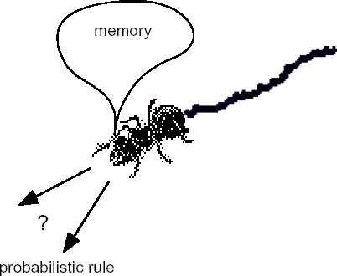

The chapter is structured as follows. Section 2 describes the common elements of the heuristics following the ACO paradigm and outlines some of the variants proposed. Section 3 presents the application of ACO algorithms to a number of different combinatorial optimization problems and it ends with a wider overview of the problem attacked by means of ACO up to now. Section 4 outlines the most significant theoretical results so far published about convergence properties of ACO variants.

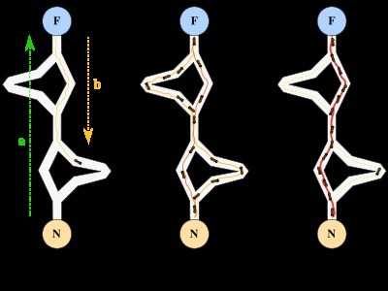

ACO is a class of algorithms, whose first member, called Ant System, was initially proposed by Colorni, Dorigo and Maniezzo . The main underlying idea, loosely inspired by the behaviour of real ants, is that of a parallel search over several constructive computational threads based on local problem data and on a dynamic memory structure containing information on the quality of previously obtained result. The collective behaviour emerging from the interaction of the different search threads has proved effective in solving combinatorial optimization (CO) problems.

we use the following notation. A combinatorial optimization problem is a problem defined over a set **C** = c*1*, ... , c*n* of basic components. A subset **S** of components represents a *solution* of the problem; **F** ⊆ 2***C*** is the subset of feasible *solutions*, thus a solution **S** is feasible if and only if **S** ∈ **F**. A cost function *z* is defined over the solution domain, z : 2***C***  **R**, the objective being to find a minimum cost feasible solution S*, i.e., to find S*: S* ∈ **F** and z(S*) ≤ z(**S**), ∀**S**∈**F**. Given this, the functioning of an ACO algorithm can be summarized as follows (see also [27]). A set of computational concurrent and asynchronous agents (a colony of ants) moves through states of the problem corresponding to partial solutions of the problem to solve. They move by applying a stochastic local decision policy based on two parameters, called trailsand attractiveness. By moving, each ant incrementally constructs a solution to the problem. When an ant completes a solution, or during the construction phase, the ant evaluates the solution and modifies the trail value on the components used in its solution. This pheromone information will direct the search of the future ants.

Furthermore, an ACO algorithm includes two more mechanisms*:* trail evaporationand, optionally, daemon actions. Trail evaporation decreases all trail values over time, in order to avoid unlimited accumulation of trails over some component. Daemon actions can be used to implement centralized actions which cannot be performed by single ants, such as the invocation of a local optimization procedure, or the update of global information to be used to decide whether to bias the search process from a non-local perspective .More specifically, an antis a simple computational agent, which iteratively constructs a solution for the instance to solve. Partial problem solutions are seen as states. At the core of the ACO algorithm lies a loop, where at each iteration, each ant moves(performs a *step*) from a state ι to another one ψ, corresponding to a more complete partial solution. That is, at each step σ, each ant *k* computes a set **A***k* σ(ι) of feasible expansions to its current state, and moves to one of these in probability. The probability distribution is specified as follows. For ant *k*, the probability pιψ*k* of moving from state ι to state ψ depends on the combination of two values:

* the attractivenessηιψ of the move, as computed by some heuristic indicating the

*a*priori desirability of that move.

* the traillevelτιψ of the move, indicating how proficient it has been in the past to make that particular move: it represents therefore an *a* posteriorindication of the desirability of that move.

Trails are updated usually when all ants have completed their solution, increasing or decreasing the level of trails corresponding to moves that were part of "good" or "bad" solutions, respectively. The general framework just presented has been specified in different ways by the authors working on the ACO approach. The remainder of Section 2 will outline some of these contributions.

The ant system simply iterates a main loop where *m* ants construct in parallel their solutions, thereafter updating the trail levels. The performance of the algorithm depends on the correct tuning of several parameters, namely: α, β, relative importance of trail and attractiveness, ρ, trail persistence, τ*ij*(0), initial trail level, *m*, number of ants, and Q, used for defining to be of high quality solutions with low cost.

The algorithm is the following.

1.{Initialization}

Initialize τιψ and ηιψ, ∀(ιψ).

2.{Construction}

For each ant k (currently in state ι) do repeat

choose in probability the state to move into.

append the chosen move to the k-th ant's set tabuk.

until ant k has completed its solution.

end for

3.{Trail update}

For each ant move (ιψ) do compute Δτιψ

update the trail matrix. end for

4.{Terminating condition}

If not(end test) go to step 2

1. **Applications OF ACO:**

### Travelling sales man:

The TSP is a very important problem in the context of Ant Colony Optimization because it is the problem to which the original AS was first applied, and it has later often been used as a benchmark to test a new idea and algorithmic variants.

###### Objective:

Given a set of *n* cities, the Traveling Salesman Problem requires a salesman to find the shortest route between the given cities and return to the starting city, while keeping in mind that each city can be visited only once

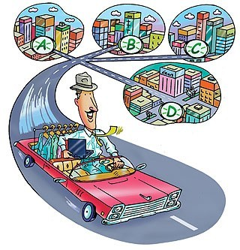

The TSP was chosen for many reasons:

* It is a problem to which the ant colony metaphor
* It is one of the most studied NP-hard problems in the combinatorial optimization
* it is very easily to explain. So that the algorithm behavior is not obscured by too many technicalities.

Since the route B is shorter, the ants on this path will complete the travel more times and thereby lay more pheromone over it.

The pheromone concentration on trail B will increase at a higher rate than on A, and soon the ants on route A will choose to follow route B

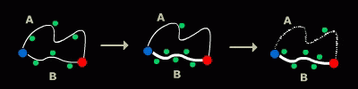Since most ants will no longer travel on route A, and since the pheromone is volatile, trail A will start evaporating Only the shortest route will remain

###### WHY TSP IS DIFFICULT TO SOLVE

Finding best solution may entail an exhaustive search for all combination of cities, this can be prohibitive as “N” gets large. Heuristic like greedy methods doesn’t guarantee optimal solutions.

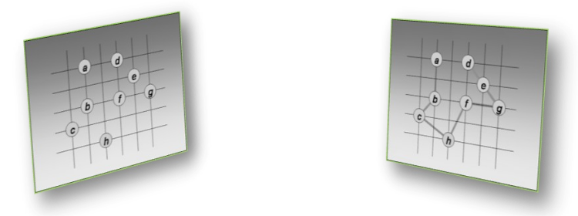

### Ant colony optimization in TSP:

The meta heuristic Ant Colony Optimization (ACO) is an optimization algorithm successfully used to solve many NP hard optimization problems introduced in ACO . ACO algorithms are a very interesting approach to find minimum cost paths in graphs especially when the connection costs in the graphs can change over time, i.e. when the problems are dynamic. The artificial ants have been successfully used to solve the (conventional) Traveling Salesman Problem (TSP) , as well as other NP hard optimization problems, including applications in quadratic assignment or vehicle routing.

The algorithm’s based on the fact that ants are always able to find the shortest path between the nest and the food sources, using information of the pheromones previously laid on the ground by other ants in the colony. When an ant is searching for the nearest food source and arrives at several possible trails, it tends to choose the trail with the largest concentration of pheromones, with a certain probability p. After choosing the trail, it deposits another pheromone, increasing the concentration of pheromones in this trail. The ants return to the nest using always the same path, depositing another portion of pheromone in the way back. Imagine then, that two ants at the same location choose two different trails at the same time. The pheromone concentration on the shortest way will increase faster than the other: the ant that chooses this way, will deposit more pheromone in a smaller period of time, because it returns earlier. If a whole colony of thousands of ants follows this behaviour, soon the concentration of pheromone on the shortest path will be much higher than the concentration in other paths. Then the probability of choosing any other way will be very small and only very few ants among the colony will fail to follow the shortest path. There is another phenomenon related with the pheromone concentration since it is a chemical substance, it tends to evaporate, so the concentration of pheromones vanishes along the time. In this way, the concentration of the less used paths will be much lower than that of the most used ones, not only because the concentration increases on the other paths, but also because its own concentration decreases.

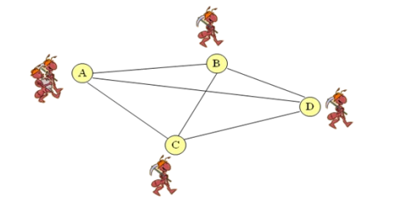

###### Flow chart for TSP using ACO:

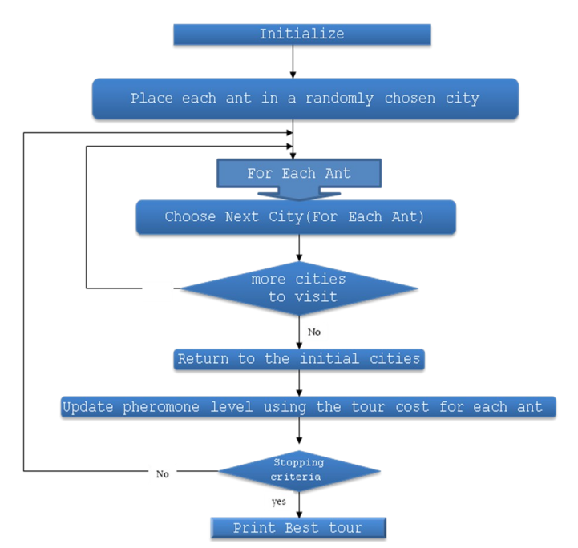

**TSP Applications:**

* Lots of practical applications
* Routing such as in trucking, delivery, UAVs
* Manufacturing routing such as movement of parts along manufacturing floor or the amount of solder on circuit board
* Network design such as determining the amount of cabling required
* Two main types
* Symmetric
* Asymmetric

### TSP Heuristics:

* Variety of heuristics used to solve the TSP
* The TSP is not only theoretically difficult it is also difficult in practical application since the tour breaking constraints get quite numerous
* As a result there have been a variety of methods proposed for the TSP
* Nearest Neighbour is a typical greedy approach

### Advantages:

* Positive Feedback accounts for rapid discovery of good solutions
* Distributed computation avoids premature convergence
* The greedy heuristic helps find acceptable solution in the early solution in the early stages of the search process.
* The collective interaction of a population of agents.

**3.2** **Quadratic Assignment Problem(QAP):**

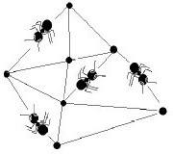

The quadratic assignment problem (QAP) is one of fundamenta[l combinatorial](http://en.wikipedia.org/wiki/Combinatorial_optimization) [optimization](http://en.wikipedia.org/wiki/Combinatorial_optimization) problems in the branch of [optimization](http://en.wikipedia.org/wiki/Optimization_(mathematics)) or [operations research](http://en.wikipedia.org/wiki/Operations_research) in [mathematics](http://en.wikipedia.org/wiki/Mathematics), from the category of the [facilities location](http://en.wikipedia.org/wiki/Facilities_location) problems.

There are a set of n facilities and a set of n locations. For each pair of locations, a distance is specified and for each pair of facilities a weigh or flow is specified (e.g., the amount of supplies transported between the two facilities). The problem is to assign all facilities to different locations with the goal of minimizing the sum of the distances multiplied by the corresponding flows

The formal definition of the quadratic assignment problem is:

* Given two sets, P ("facilities") and L ("locations"), of equal size, together with a [weight function](http://en.wikipedia.org/wiki/Weight_function) w : P × P → [R](http://en.wikipedia.org/wiki/Real_number) and a distance function d : L× L → [R](http://en.wikipedia.org/wiki/Real_number). Find the [bijection](http://en.wikipedia.org/wiki/Bijection) f : P → L ("assignment") such that the [cost function](http://en.wikipedia.org/wiki/Cost_function):



is minimized.

* Usually weight and distance functions are viewed as square real- valued matrices, so that the cost function is written down as:



Problem is:

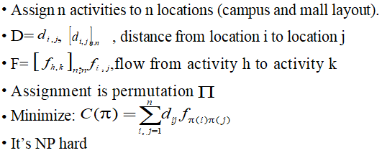

#### QAP Example:

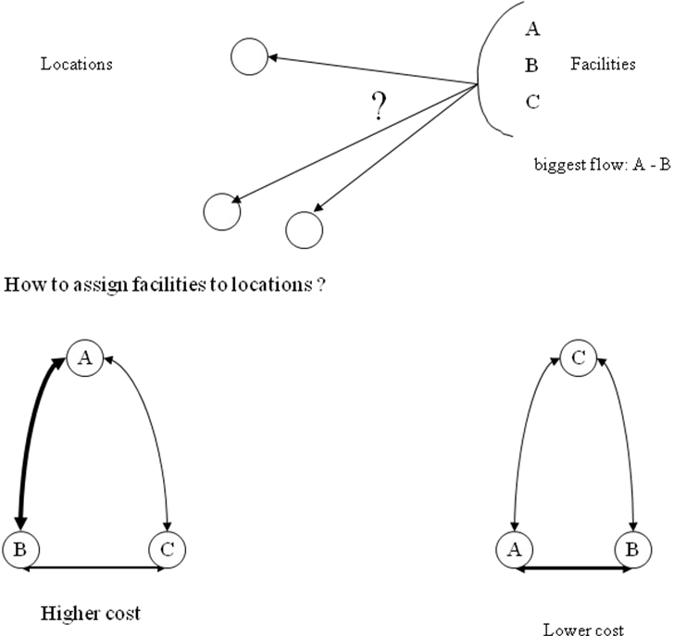

### **3.3** Network Model:

Routing (or routeing) is the process of selecting paths in a network along which to send network traffic. Routing is performed for many kinds of networks, including t[he telephone](http://en.wikipedia.org/wiki/PSTN) [network](http://en.wikipedia.org/wiki/PSTN), [electronic data networks](http://en.wikipedia.org/wiki/Computer_network) (such as the [Internet](http://en.wikipedia.org/wiki/Internet)), and [transportation networks](http://en.wikipedia.org/wiki/Transport_network). This article is concerned primarily with routing in electronic data networks using [packet](http://en.wikipedia.org/wiki/Packet_switching) [switching](http://en.wikipedia.org/wiki/Packet_switching) technology.

In packet switching networks, routing directs [packet forwarding](http://en.wikipedia.org/wiki/Packet_forwarding), the transit of logically addressed packets from their source toward their ultimate destination through intermediate [nodes](http://en.wikipedia.org/wiki/Node_(networking)); typically hardware devices called [routers](http://en.wikipedia.org/wiki/Router), [bridges](http://en.wikipedia.org/wiki/Network_bridge), [gateways](http://en.wikipedia.org/wiki/Gateway_(telecommunications)), [firewalls](http://en.wikipedia.org/wiki/Firewall_(computing)), or [switches](http://en.wikipedia.org/wiki/Network_switch). General-purpose [computers](http://en.wikipedia.org/wiki/Computer) with multiple [network cards](http://en.wikipedia.org/wiki/Network_card) can also forward packets and perform routing, though they are not specialized hardware and may suffer from limited performance. The routing process usually directs forwarding on the basis of [routing](http://en.wikipedia.org/wiki/Routing_table) [tables](http://en.wikipedia.org/wiki/Routing_table) which maintain a record of the routes to various network destinations. Thus, constructing routing tables, which are held in the routers' [memory](http://en.wikipedia.org/wiki/Computer_storage), is very important for efficient routing. Most routing algorithms use only one network path at a time, but [multipath](http://en.wikipedia.org/wiki/Multipath_routing) [routing](http://en.wikipedia.org/wiki/Multipath_routing) techniques enable the use of multiple alternative paths.

Routing task is performed by Routers.

Routers use “Routing Tables” to direct the data.

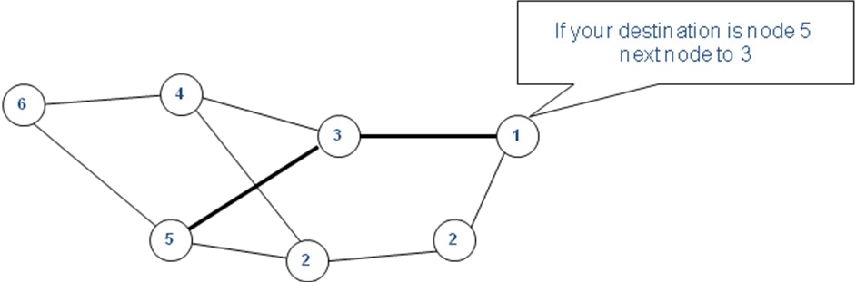

**Problem statement:**

* Dynamic Routing
* At any moment the pathway of a message must be as small as possible. (Traffic conditions and the structure of the network are constantly changing)
* Load balancing
* Distribute the changing load over the system and minimize lost calls

**Example:**

**Node8 Node1**

**Node3**

**Node7**

**Node4**

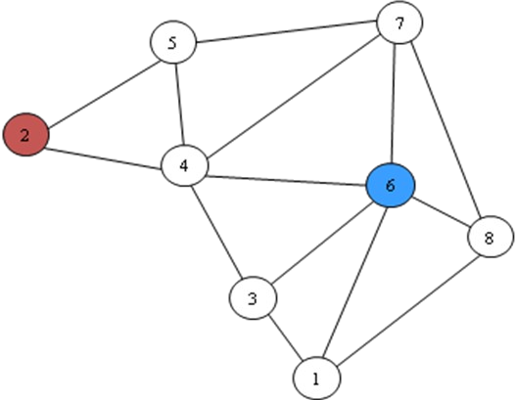

**3.4 Vehicle Routing Problem with Time Windows (VRPTW):**

The vehicle routing problem (VRP) is a [combinatorial optimization](http://en.wikipedia.org/wiki/Combinatorial_optimization) and [integer](http://en.wikipedia.org/wiki/Integer_programming) [programming](http://en.wikipedia.org/wiki/Integer_programming) problem seeking to service a number of customers with a fleet of vehicles. Proposed by Dantzig and Ramser in 1959, VRP is an important problem in the fields of transportation, distribution and logistics.[[1]](http://en.wikipedia.org/wiki/Vehicle_routing_problem#cite_note-0)Often the context is that of delivering goods located at a central depot to customers who have placed orders for such goods. Implicit is the goal of minimizing the cost of distributing the goods. Many methods have been developed for searching for good solutions to the problem, but for all but the smallest problems, finding global minimum for the cost function is [computationally complex](http://en.wikipedia.org/wiki/Computational_complexity_theory).

###### 

###### Objective Functions to Minimize:

* Total travel distance
* Total travel time
* Number of vehicles

###### Subject to:

* Vehicles ( # ,Capacity, time on road, trip length)
* Depots (Numbers)
* Customers (Demands, time windows)

###### Vehicle Routing Problem with Time Windows (VRPTW):

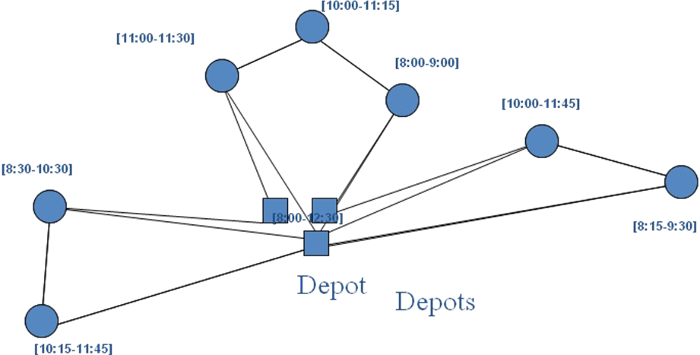

**Multiple ACS For VRPTW:**

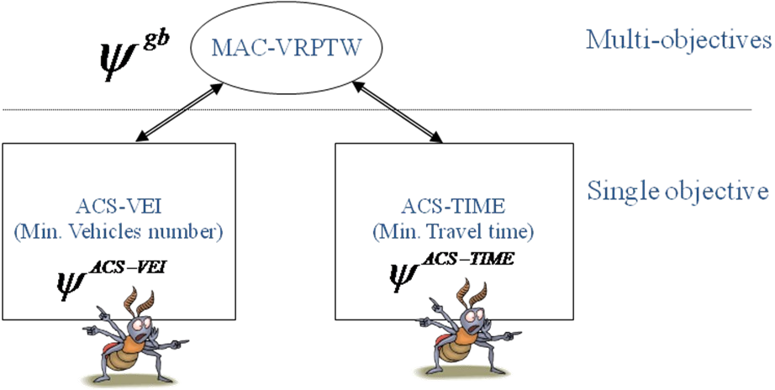

1. **ADVANTAGES OF ACO:**

* Inherent parallelism.
* Ants works in parallel to find a solution.
* Parallelism at the level of data.
* Ants working for sub-problems
* Efficient for several problems like TSP, QAP.
* Positive feedback which accounts for rapid discovery of good solution
* Can be used in dynamic application(Adapts to change such as new distances etc)

### DISADVANTAGES OF ACO:

* Theoretical analysis is difficult.
* Probabilistic distribution changes by iteration.
* Research is experimental rather than theoretical.
* Time to converge is uncertain.

### CONCLUSIONS:

* ACO is a recently proposed metaheuristic approach for solving hard combinatorial optimization problems.
* Artificial ants implement a randomized construction heuristic which makes probabilistic decisions.
* The a cumulated search experience is taken into account by the adaptation of the pheromone trail.
* ACO Shows great performance with the “illstructured” problems like network routing.
* In ACO Local search is extremely important to obtain good results.

1. **REFERENCES:**

* Dorigo M. and G. Di Caro (1999). The Ant Colony Optimization Meta-Heuristic. In D. Corne, M. Dorigo and F. Glover, editors, New Ideas in Optimization, McGraw-Hill, 11-32.
* M. Dorigo and L. M. Gambardella. Ant colonies for the travelling salesman problem. Bio Systems, 43:73–81, 1997.
* M. Dorigo and L. M. Gambardella. Ant Colony System: A cooperative learning approach to the travelling salesman problem.
* IEEE Transactions on Evolutionary Computation, 1(1):53–66, 1997.
* G. Di Caro and M. Dorigo. Mobile agents for adaptive routing. In H. El-Rewini, editor,
* Proceedings of the 31st International Conference on System Sciences (HICSS-31), pages 74–83. IEEE Computer Society Press, Los Alamitos, CA, 1998.
* M. Dorigo, V. Maniezzo, and A. Colorni. The Ant System: An autocatalytic optimizing process. Technical Report 91-016 Revised, Dipartimento di Elettronica, Politecnico di Milano, Italy, 1991.
* L. M. Gambardella, ` E. D. Taillard, and G. Agazzi. MACS-VRPTW: A multiple ant colony system for vehicle routing problems with time windows. In D. Corne, M. Dorigo, and F. Glover, editors, New Ideas in Optimization, pages 63–76. McGraw Hill, London, UK, 1999.
* L. M. Gambardella, ` E. D. Taillard, and M. Dorigo. Ant colonies for the quadratic assignment problem. Journal of the Operational Research Society, 50(2):167–176, 1999.
* V. Maniezzo and A. Colorni. The Ant System applied to the quadratic assignment problem. IEEE Transactions on Data and Knowledge Engineering, 11(5):769–778, 1999.
* Gambardella L. M., E. Taillard and M. Dorigo (1999). Ant Colonies for the Quadratic Assignment Problem. Journal of the Operational Research Society, 50:167-176.